# Project Introduction

The World Health Organisation (WHO) has declared the coronavirus disease 2019 (COVID-19) an epidemic. a worldwide coordinated effort is required to prevent the additional unfold of the virus. an epidemic is outlined as “occurring over a wide geographic region associated touching an exceptionally high proportion of the population. The last pandemic reported within the world was the H1N1 flu pandemic in 2009.

On thirty-one December 2019, a cluster of cases of respiratory disorder of unknown cause, within the town or the city, Hubei province in China, was reported to the globe Health Organisation. In January 2020, an antecedently unknown new virus was known, later on, named the 2019 novel coronavirus, and samples obtained from cases and analysis of the virus’ biology indicated that this was the explanation for the irruption. This novel coronavirus was named Coronavirus malady 2019 (COVID-19) by UN agency in Feb 2020. The virus is brought up as SARS-CoV-2 and also the associated malady is COVID-19.

As of 15 may 2020, over 4,444,670 cases are known globally in 188 countries with a complete of over 302,493 fatalities. Also 1,588,858 were recovered

**Clinical Presentation**

Those who do develop symptoms may have a mild to moderate, but self-limiting disease with symptoms similar to the seasonal flu. Symptoms may include:

* Respiratory symptoms
* Fever
* Cough
* Shortness of breath
* Breathing difficulties
* Fatigue
* Sore throat

**Transmission of COVID-19**

Evidence continues to be rising, however current info is indicating that human-to-human transmission is happening. The routes of transmission of COVID-19 remains unclear at the present, however, proof from alternative coronaviruses and metabolism illness indicates that the disease could unfold through giant metabolism droplets and direct or indirect contact with infected secretions.

The period of COVID-19 is presently understood to be between a pair of to fourteen days. this implies that if an individual remains well once fourteen days once being up-to-date with an individual with confirmed COVID-19, they're not infected.

# Analysis OBjectives

Here are the list of question whose analysis whgich be given below..

1. Which of the continents most effected by Covid-19?
2. What is the relation between cases of covid vs Deaths due to covid-19?
3. Which of the continents have large cases of corona and more casualities(deaths)?
4. Country wise confirmed and Fatalities/Death cases plotting
5. Continent wise confirmed and Fatalities/Death cases plotting
6. What is the population of top 20 countries in 2019 which is badly effected by COVID-19?
7. What is the Cumulative number for 14 days of COVID-19 in top 20 Countries?

# Data Acquisition and Cleaning

**Code to read the data from Excel / CSV / HTML.**

To read the dataset in csv format, we will load it into Pandas data frame but first let’s import the pandas library and set an alias by typing **“import pandas as pd”**. After importing the library with the alias **“pd”**, let us load the .csv file using the following line of code:

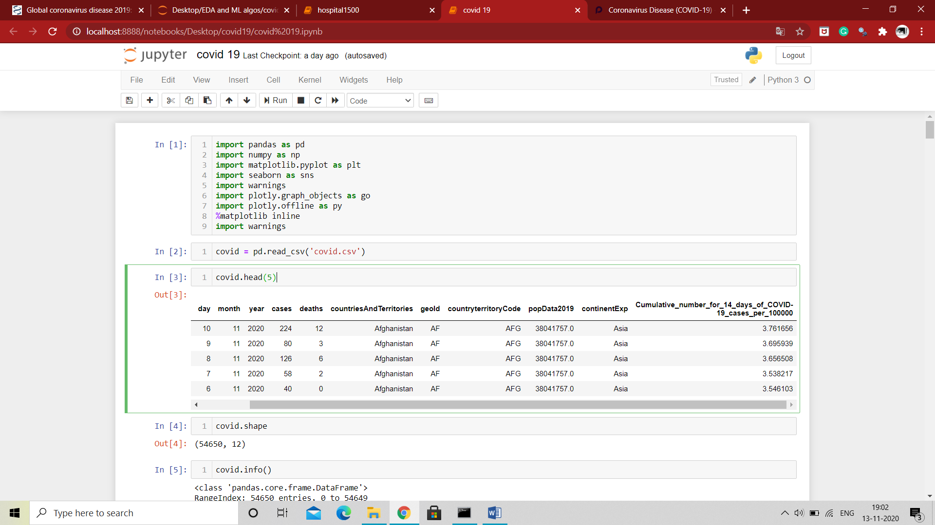

Here we have import our csv files and read through pandas library.

Here the csv file can be read through (Pandas library) and store in **covid Dataframe**. The Dataframe can be shown through **.head()**. The number of rows we want to show, that number we have to pass in head parentheses as an argument.

Now if we want to describe our dataframe for our better understanding to know the stats. and other parameter that our dataset should follow

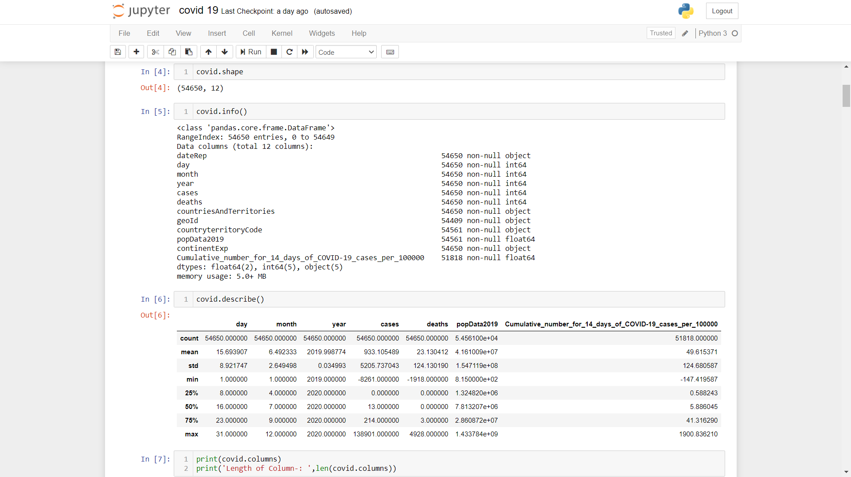

**Clean the unnecessary data, by removing, replace the missing data and renaming the columns.**

Dataset generally contains some null value, which is generally caused by misplacing some values. So its necessary to clean this mess from our dataset for better visualization

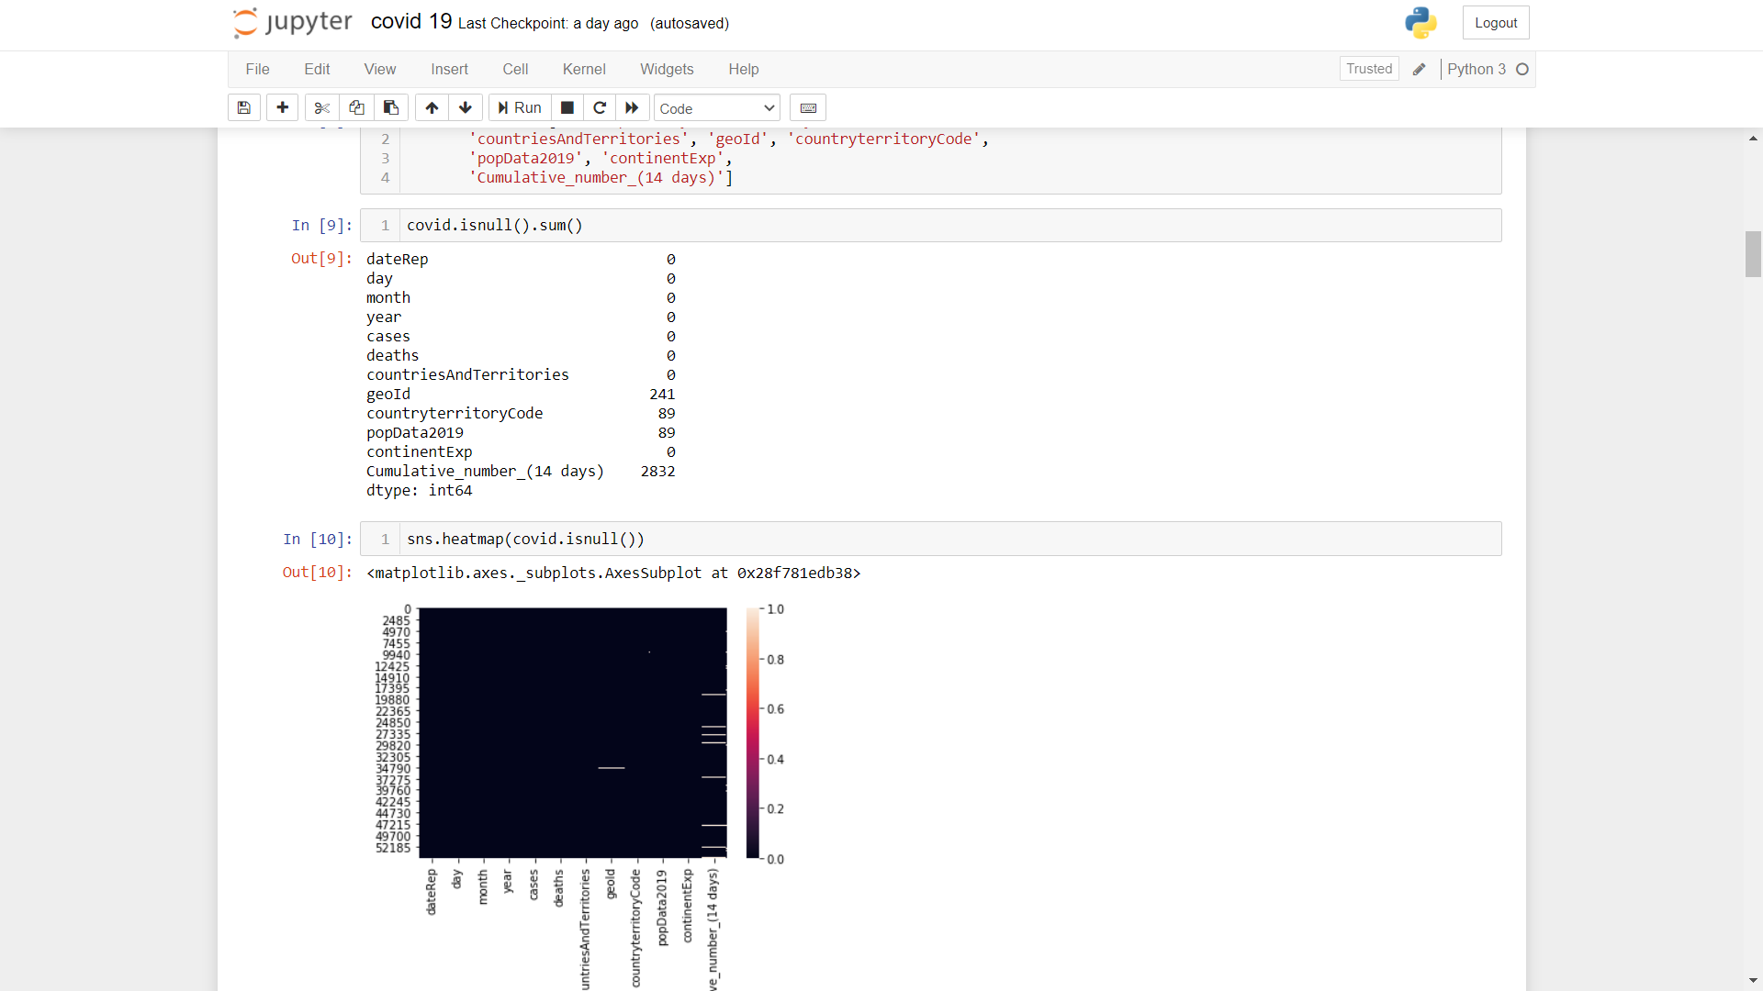

In the above diagram we see that some of the columns of this dataset contains null value.

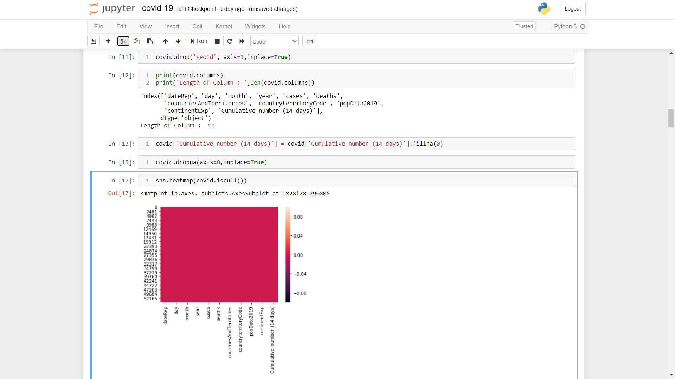

In the process of data cleaning we first drop the particular column name **geoId** which contains atmost null value. Then subsequently we fill the other null values column with its mean value or 0, so that the values will not much more effect. Finally after all process our heatmap diagram shows coloured which indicated that our dataset is almost clean.

**why data clean needed (for your data)**

Data cleansing or scrubbing or appending is the procedure of correcting or removing inaccurate and corrupt data. This process is crucial and emphasized because wrong data can drive a business to wrong decisions, conclusions, and poor analysis, especially if the huge quantities of big data are into the picture.

# Data and Exploratory Analysis

**Code and its output with Explanation**

1. **Which of the continents most effected by Covid-19?**

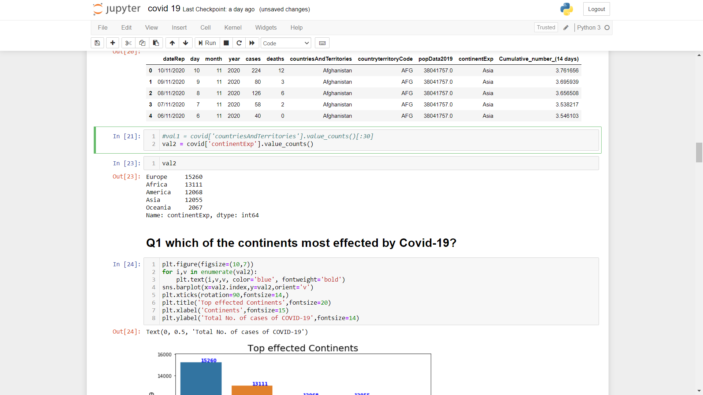

This counts all the Continents which are badly effected by COVID-19 ,As the output is given in screenshot.

1. **What is the relation between cases of covid vs Deaths due to covid-19?**

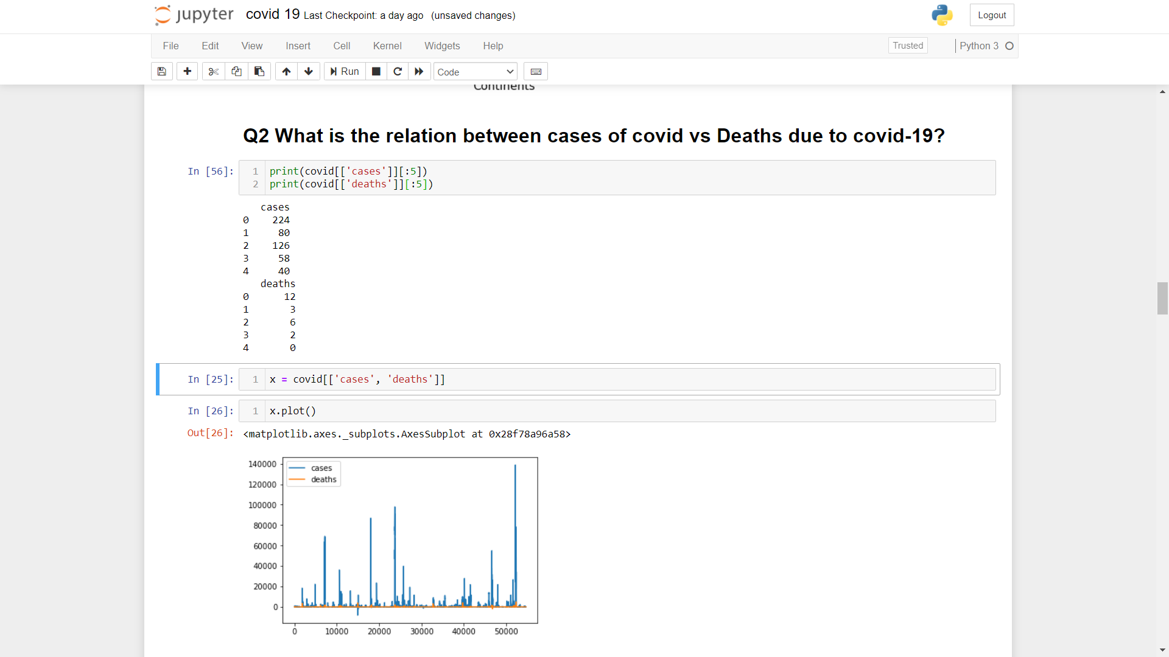

Here our main motto is to show relation between total number of cases and deaths due to covid-19. This shows how many cases occur and susequently deaths occour.

1. **Which of the continents have large cases of corona and more casualities(deaths)?**

The Continents which are badly affeced by COVID-19 are separated out and store them in an individual dataframe. This will helps us to make us understand more in other aspects also.

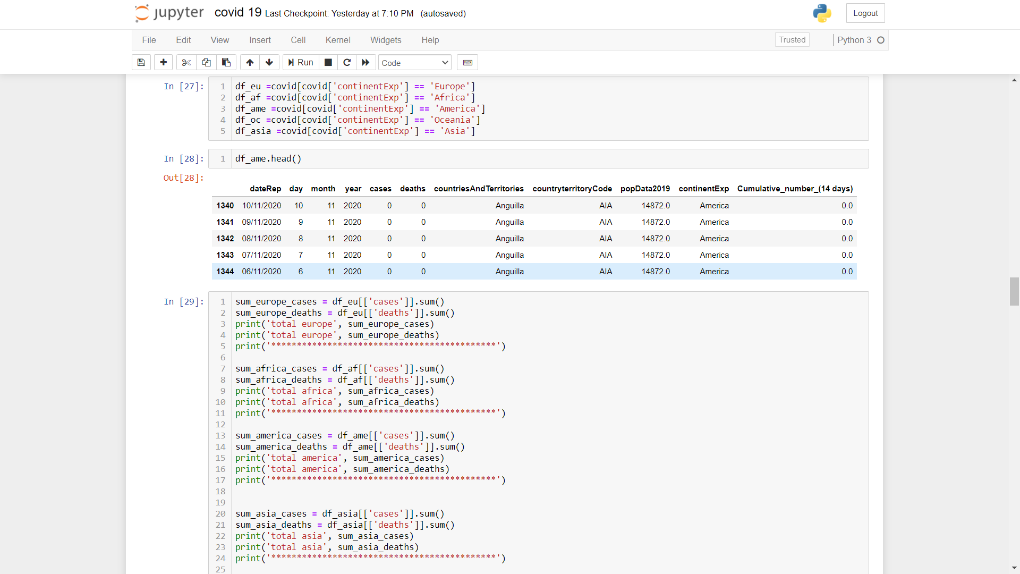

Here we classified all five Continents into separate dataframe. Now we can easily performs some operation on each dataset of different Continents.

The basic operation performed on each separated dataset are

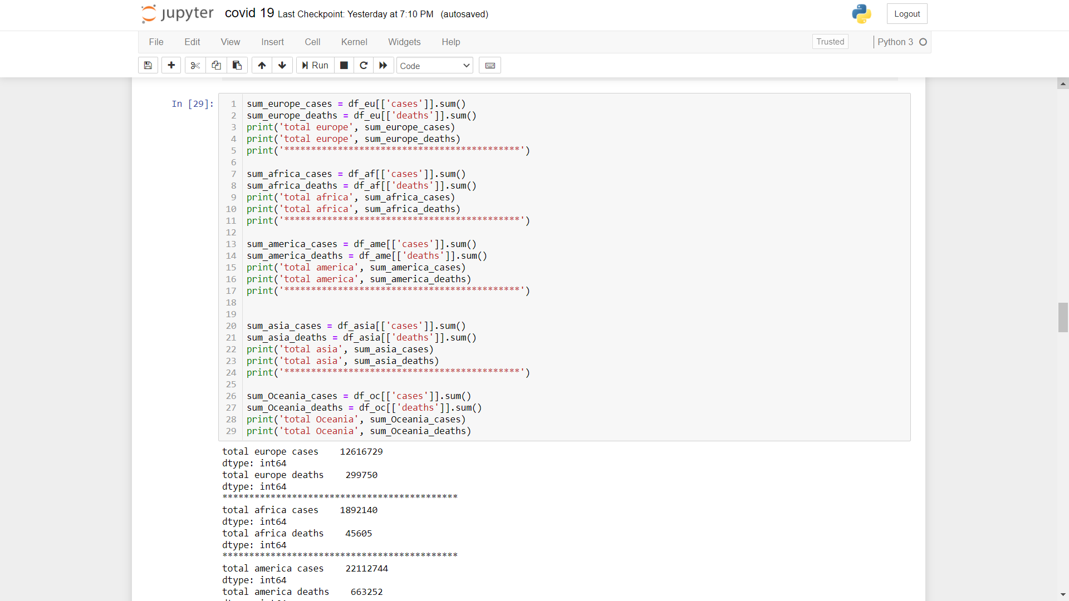

Here we can sum up all the total number of cases and total number of deaths that would happen in all Continents.

The output for this given below

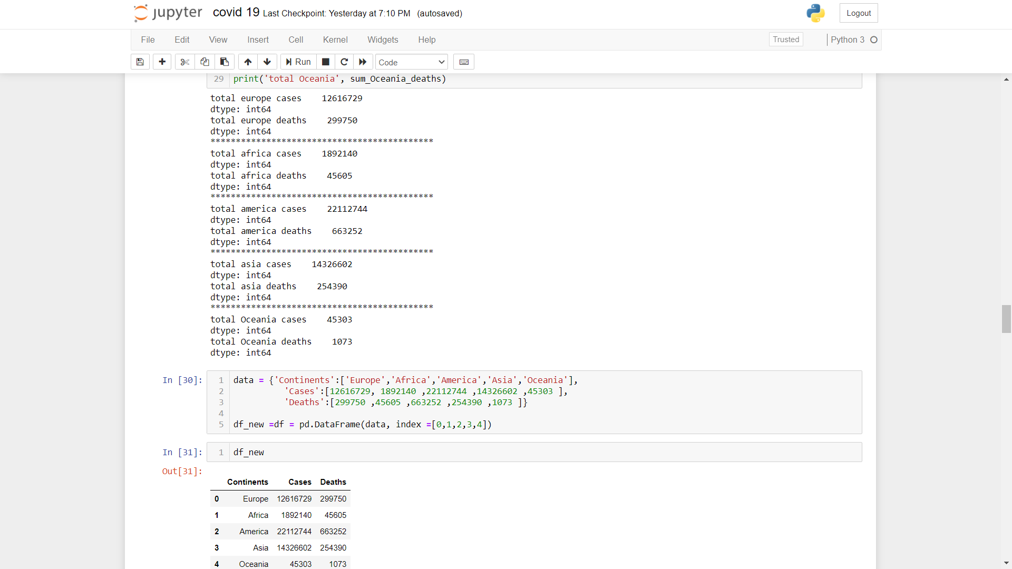

1. **Country wise confirmed and Fatalities/Death cases plotting**

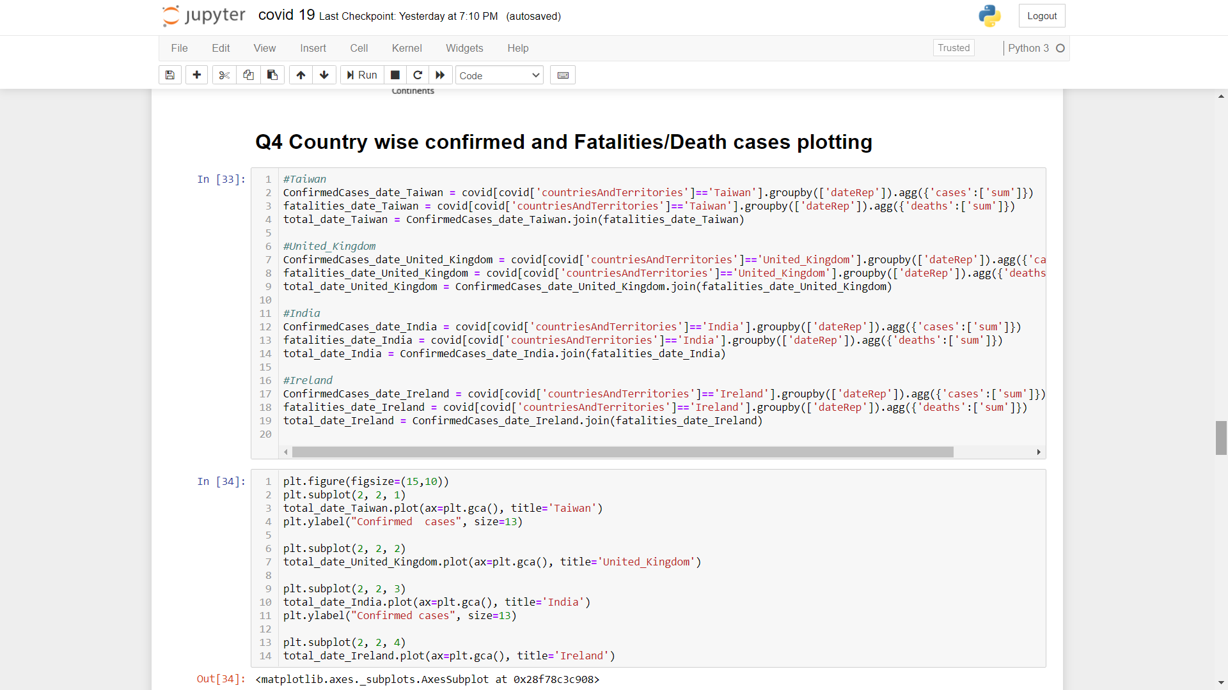

Based on our top priorities of Country, their top cases and deaths rates due to covid 19. In each we sum all the covid cases and deaths number and then group by dates. All this operation be put into a separate dataframe. Same operation will performed in all the cases.

1. **Continent wise confirmed and Fatalities/Death cases plotting**

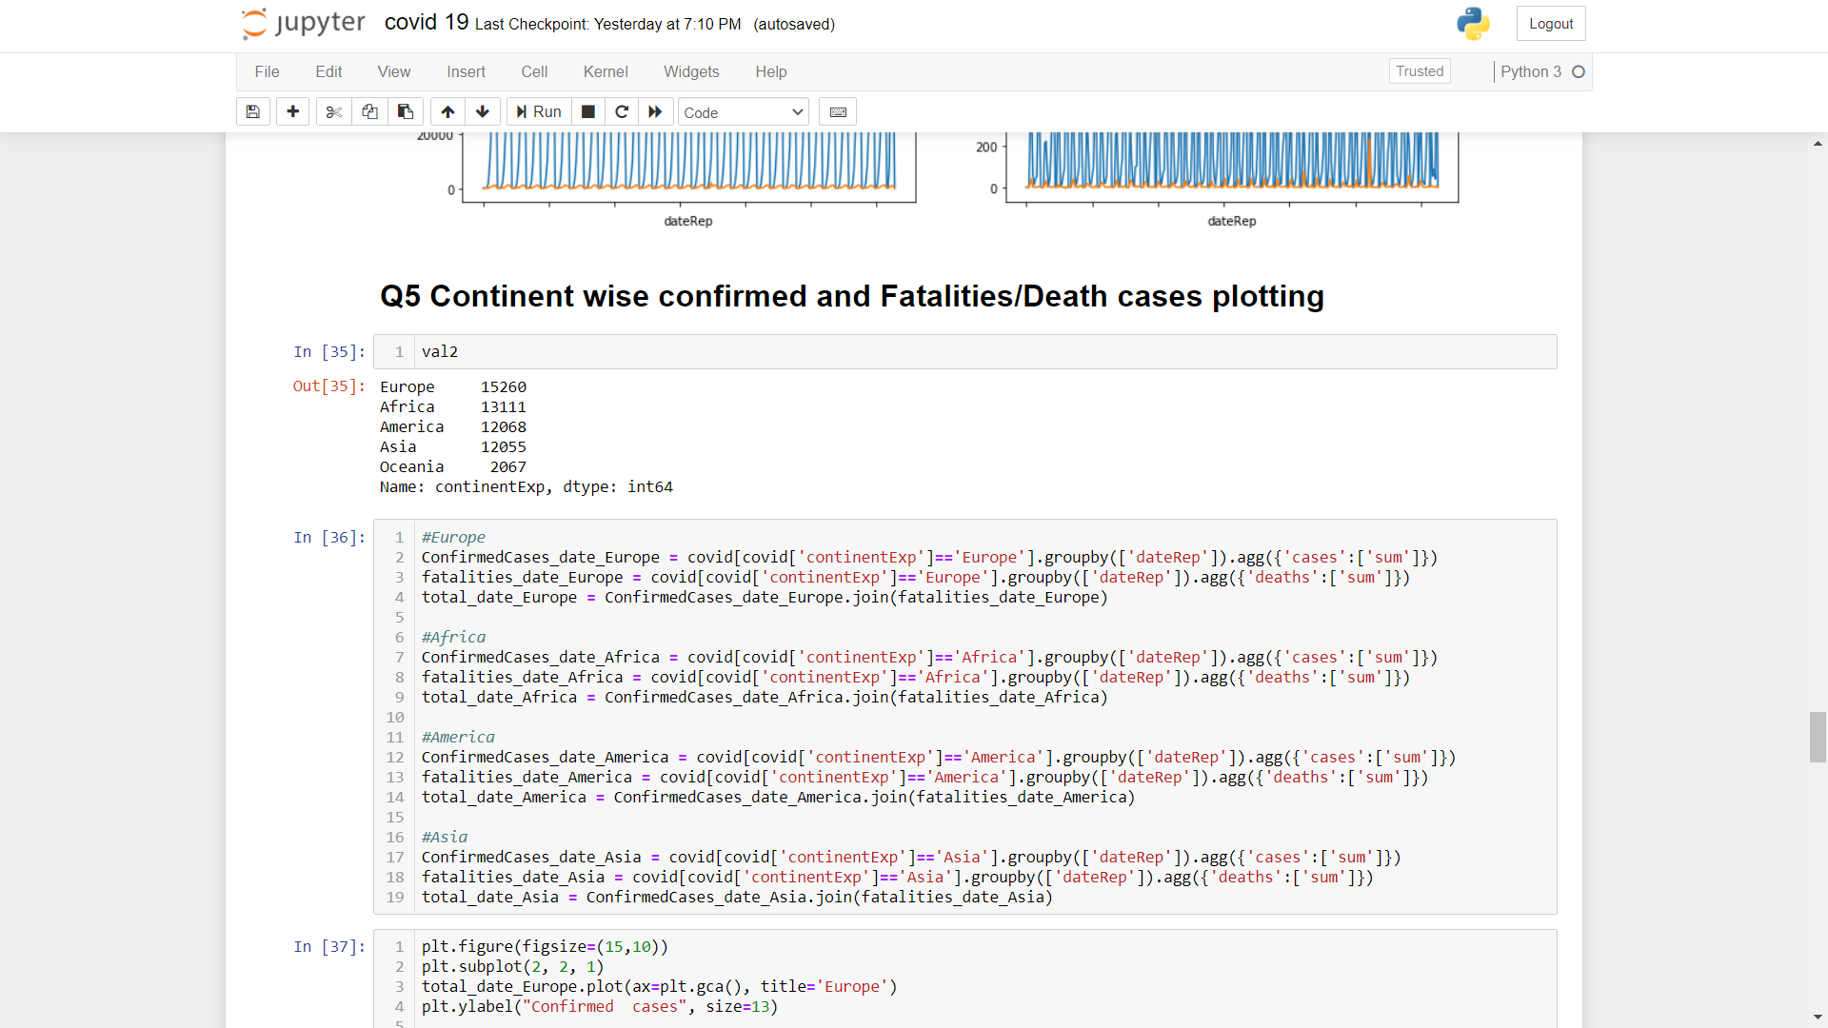

Based on our top priorities of Continents , their top cases and deaths rates due to covid 19. In each we sum all the covid cases and deaths number and then group by dates. All this operation be put into a separate dataframe. Same operation will performed in all the cases.

1. **What is the population of top 20 countries in 2019 which is badly effected by COVID-19?**

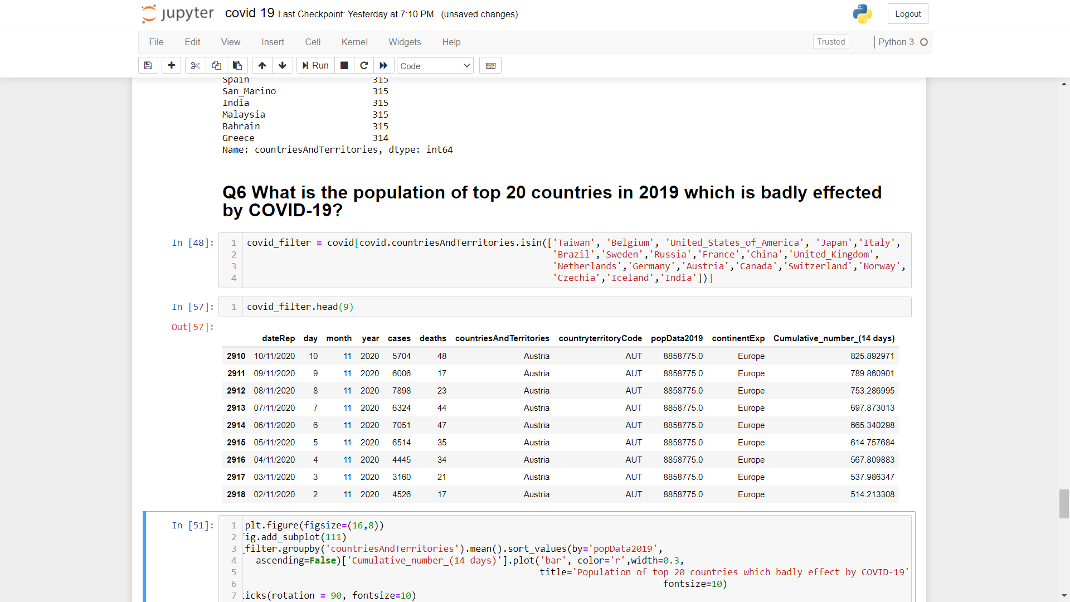

We selected the top 20 effected covid-19 Countries and visualise them according to their population in 2019.

1. **What is the Cumulative number for 14 days of COVID-19 in top 20 Countries?**

From all Countries we selected our top 20such countries whose rate of corona spread rate is more.



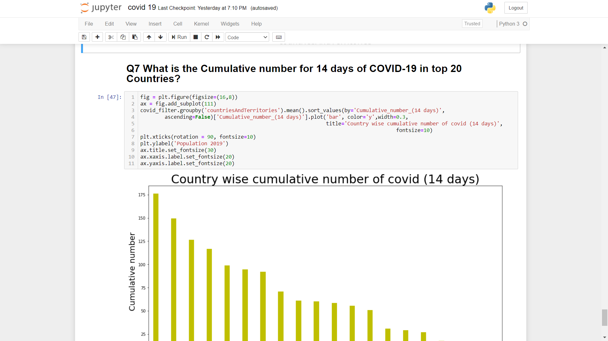

So this dataset will help us to visualize the cumulative number of covid 19 in such top effected countries.

# Data Analysis – Visualization

**Code and its output with vizualization**

1. **Which of the continents most effected by Covid-19?**

**Code:-**



This counts all the Continents which are badly effected by COVID-19 ,As the output is given in screenshot.

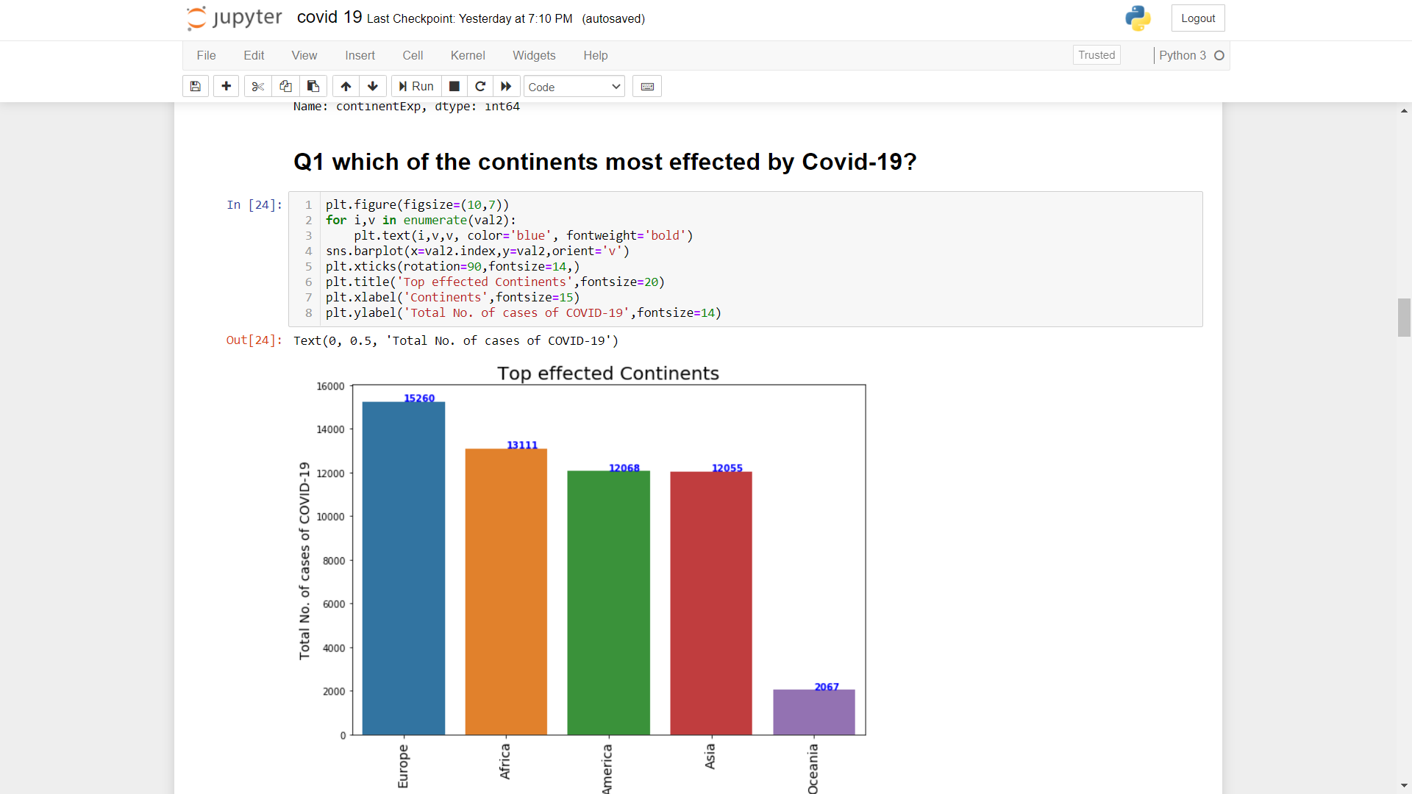

**Output:-**

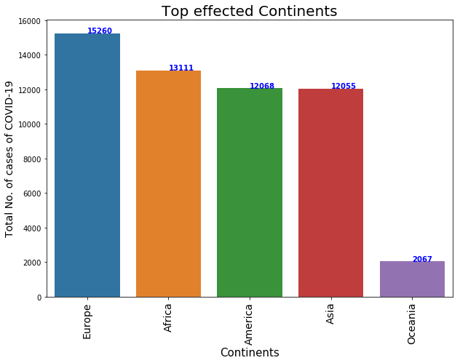

This visualization shows total no. of cases of covid 19 in these different continents.

1. **What is the relation between cases of covid vs Deaths due to covid-19?**

**Code:-**

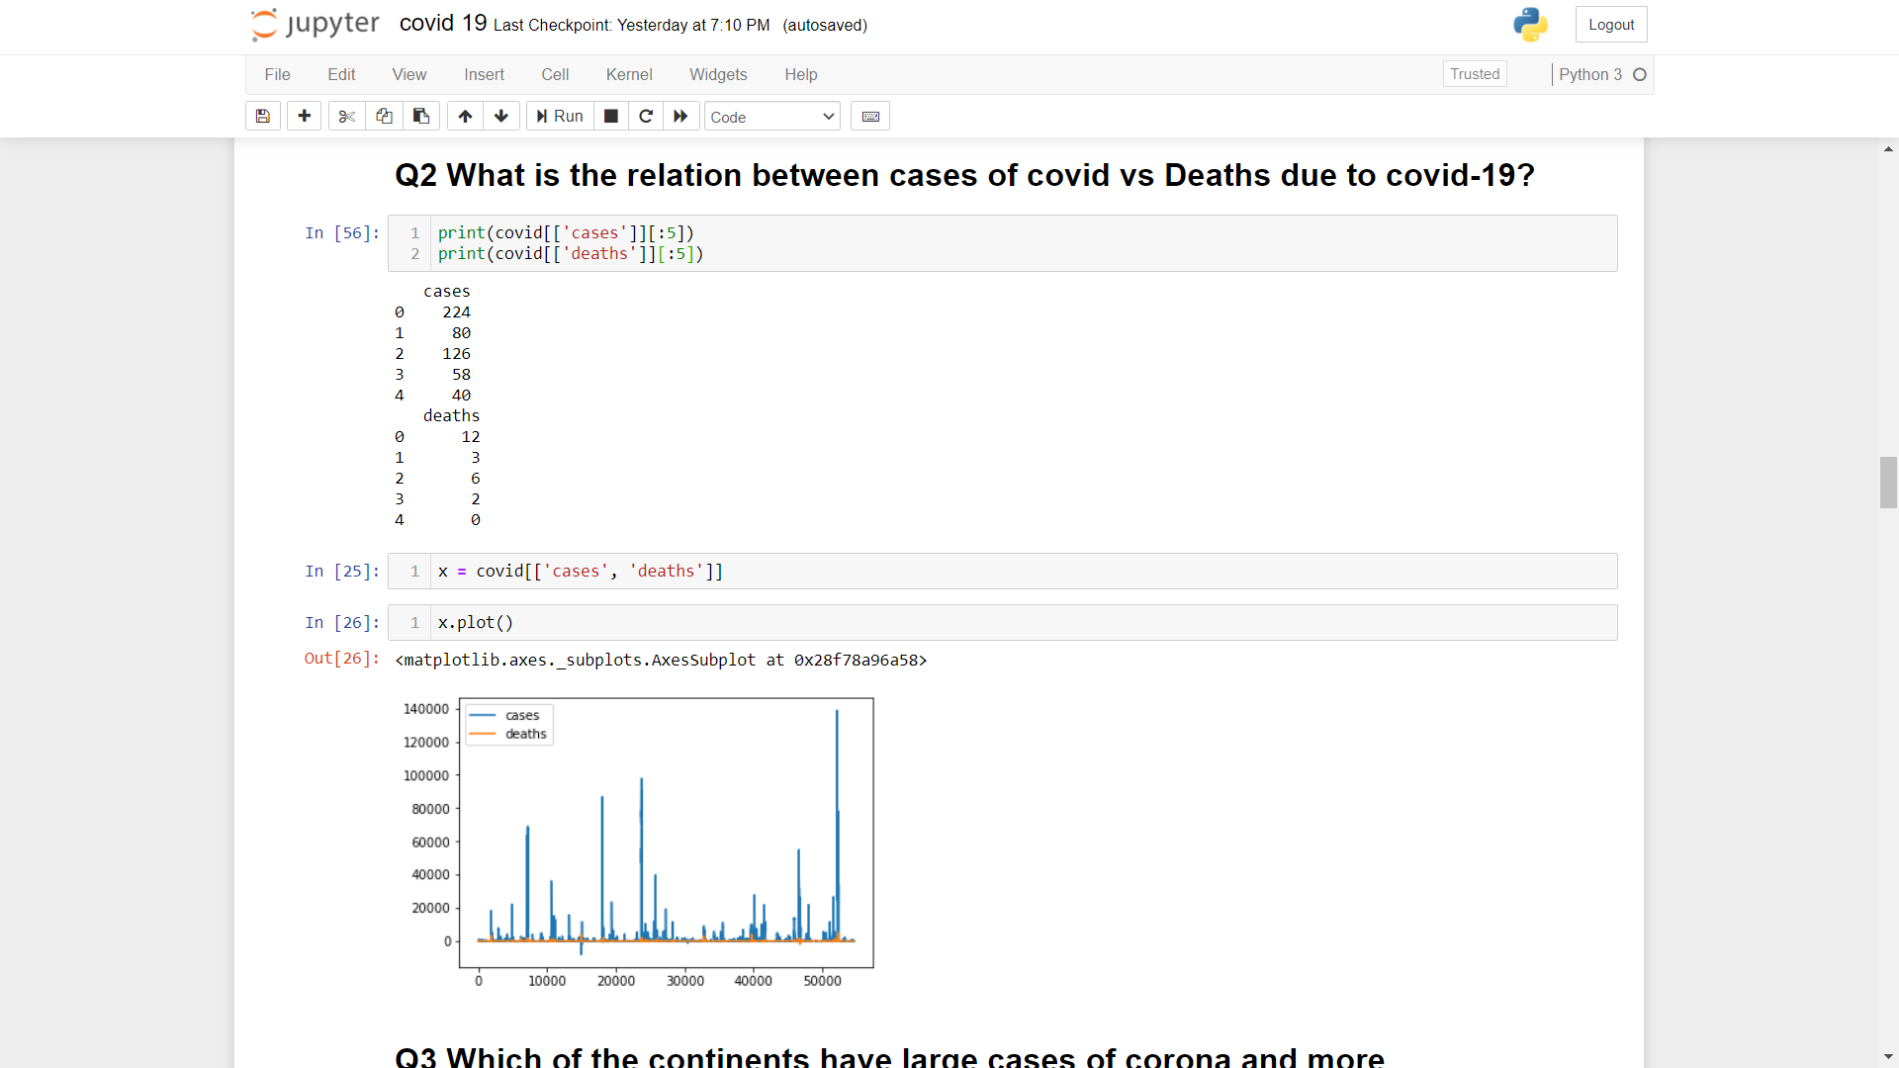

Here our main motto is to show relation between total number of cases and deaths due to covid-19. Then we put into dataframe x variable and visualization given below

**Output:-**



This is the graphical representation of total number of cases and deaths that caused due to covid 19. From this graph one can analyse that the ratio of spreading disease is much more than that of deaths. Hence it is a communicable disease, one should take care of themselves by **Wearing mask**.

1. **Which of the continents have large cases of corona and more casualities(deaths)?**

**Code:-**

The Continents which are badly affeced by COVID-19 are separated out and store them in an individual dataframe.



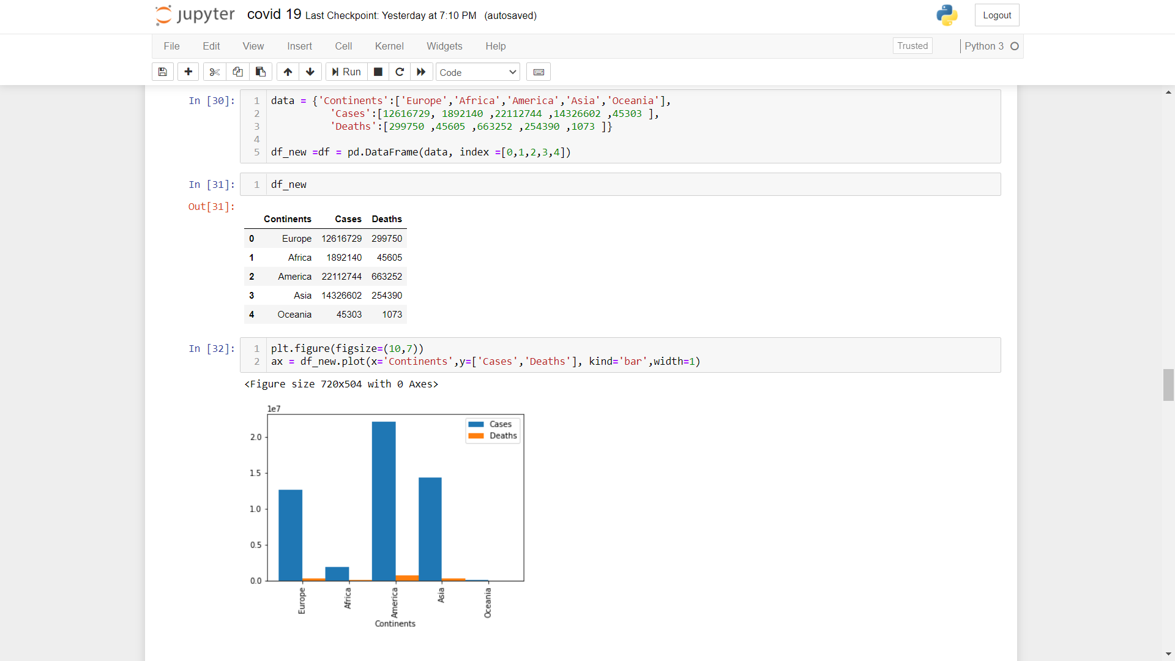

**Output:-**



1. **Country wise confirmed and Fatalities/Death cases plotting**

**Code:-**



Based on our top priorities of Country, their top cases and deaths rates due to covid 19. In each we sum all the covid cases and deaths number and then group by dates.

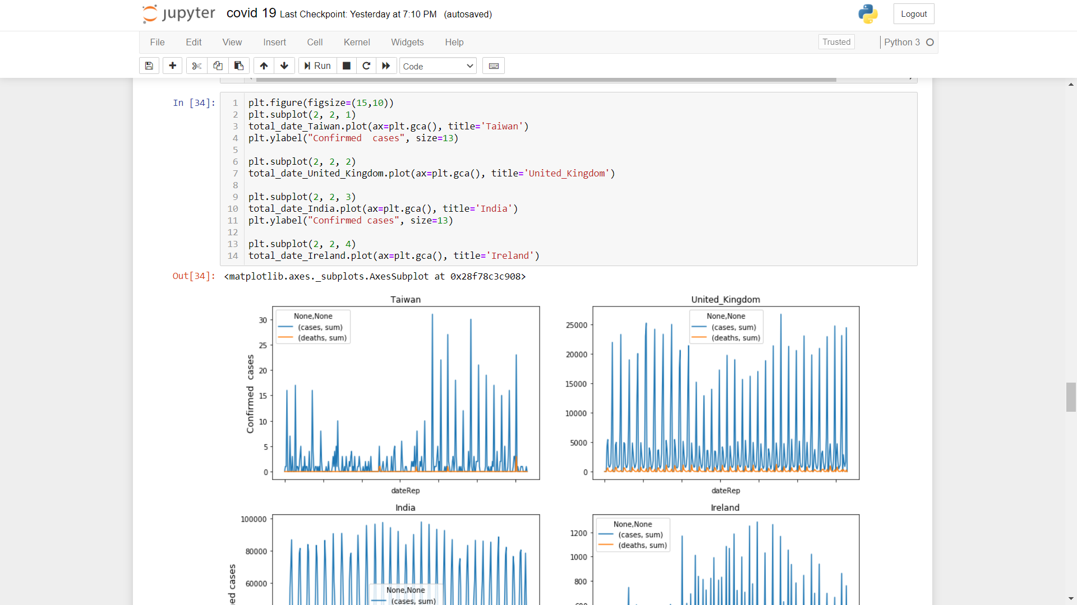

**Output:-**

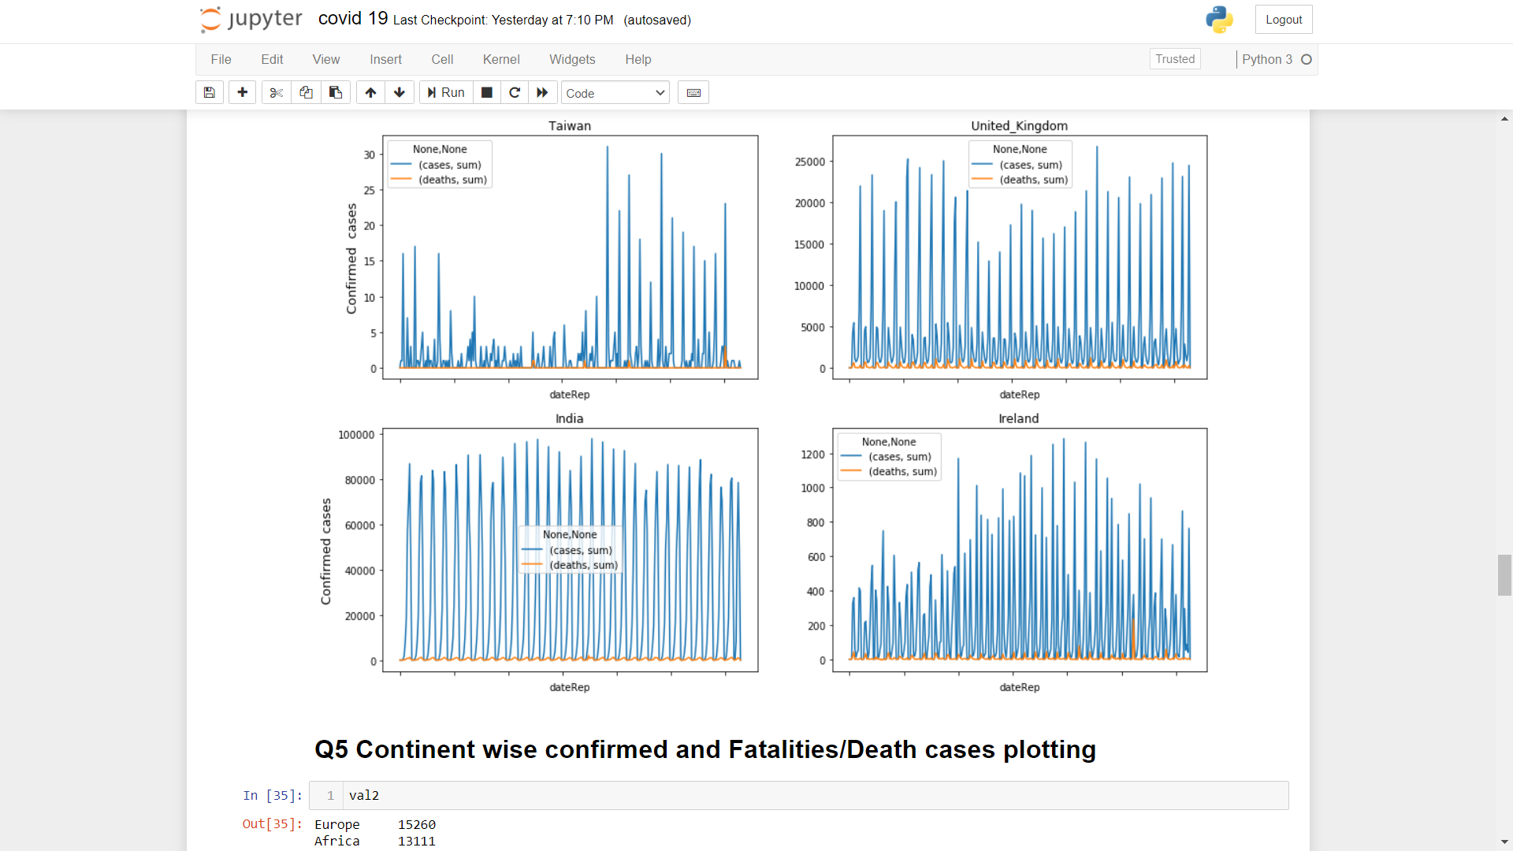

1. **Continent wise confirmed and Fatalities/Death cases plotting**

**Code:-**



Based on our top priorities of Continents , their top cases and deaths rates due to covid 19

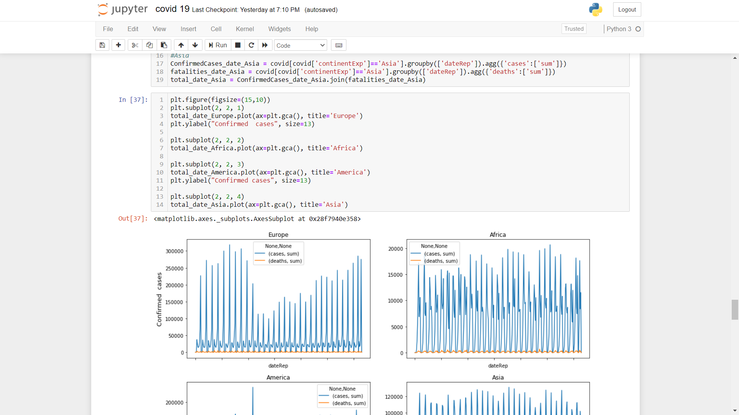

**Output:-**

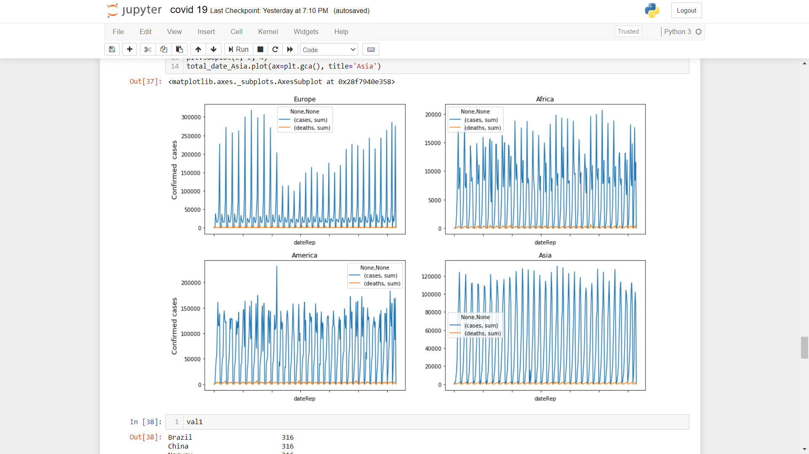

1. **What is the population of top 20 countries in 2019 which is badly effected by COVID-19?**

**Code:-**



We selected the top 20 effected covid-19 Countries and visualise them according to their population in 2019.

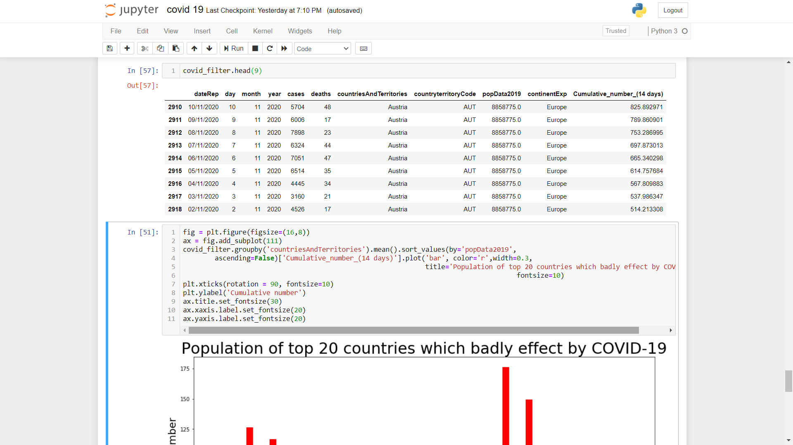

**Output:-**

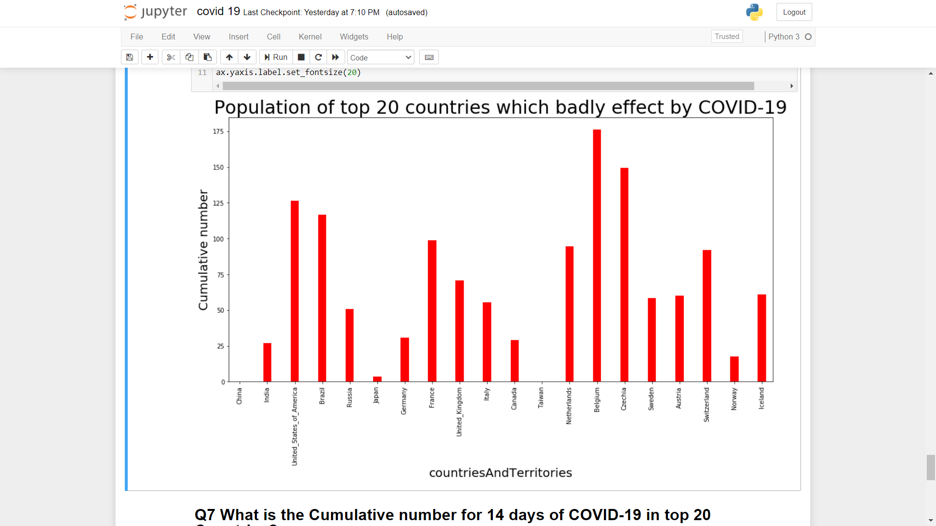

1. **What is the Cumulative number for 14 days of COVID-19 in top 20 Countries?**

**Code:-**





So this dataset will help us to visualize the cumulative number of covid 19 in such top effected countries.

**Output:-**

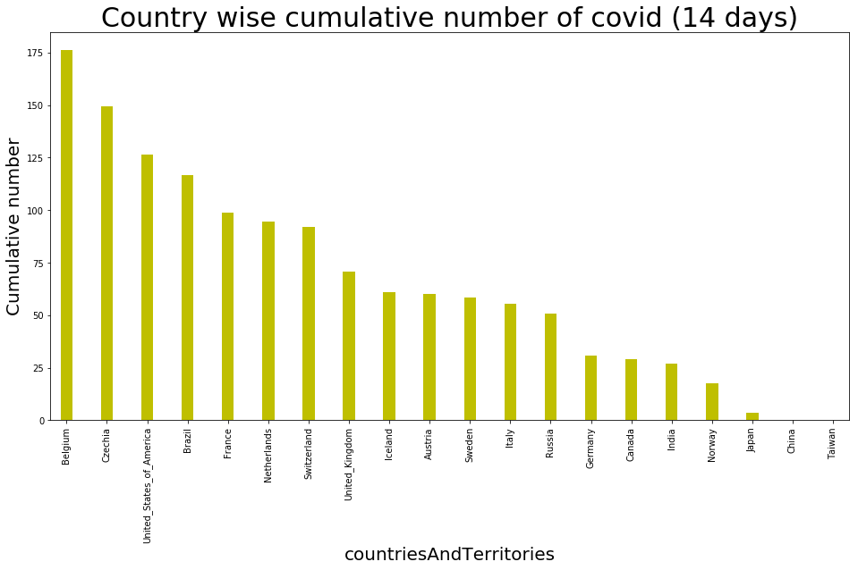

This graph shows the cumulative number of covid 19 for top 20 countries, which ae badly effected by covid.

# Executive Summary

**CONCLUSION**

A pandemic isn't new in human history. however what makes the COVID-19 pandemic special is that it takes place in associate degree unprecedented scene once the interconnectivity and reciprocity between folks, between countries and between continents ar therefore deep. The achievements folks have created in technology, intelligence and transportation create them each physically and psychologically globalized.

The consequence is that issues in one country can become international ones. way back we tend to raised warnings, and that we cannot underestimate the danger of transnational threats, from terrorist act to cybercrimes.

Similarly, if one isolates oneself and depends on others to resolve one's own issues, it's merely not possible. The result of the virus has clearly established this. The pandemic reminds the North American nation that we'd like to remain humble within the face of disasters.

**Pros and cons..**

**PROS**

* Covid-19 has brought the world to a grinding halt.
* The global suffering has led to introspection – being kind to ourselves and others and encouraging us to build bridges across geographical barriers.
* Humans are not indestructible and life is unpredictable. The pandemic has made these distant statements crystal clear for us.

**CONS**

* COVID-19 has put millions on the edge, and everyone was suddenly placed in a state of emergency
* With the sudden closure of schools, most parents were at a loss and ill-prepared
* Most health care workers' biggest fear: bringing coronavirus home

# References

* [www.globaltimes.cn](http://www.globaltimes.cn)
* <https://data.europa.eu/euodp/en/data>
* <https://en.wikipedia.org/wiki/COVID-19_pandemic_in_India>